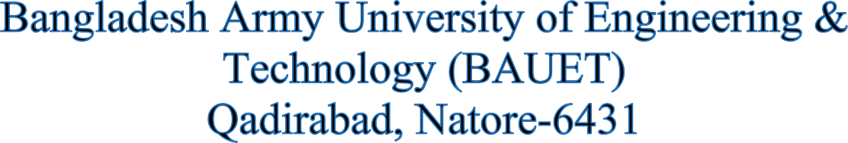



**Department of**

**Computer Science and Engineering (CSE)**

**Lab Report**

**Course Code : CSE-2212**

**Course Title : Database Management System Sessional**

**Experiment No :** 01

**Experiment Name:** Introduction to Database Management System Concept.

**Date of Experiment:** 23/06/2024

**Date of Submission :** 30/06/2024

# **SUBMITTED TO:**

**Md. Omar Faruq**

Assistant Professor,

Dept. of CSE, BAUET.

**Md Rafiqul Islam**

Lecturer, Dept. of CSE,

BAUET.

# **SUBMITTED BY:**

Name : Md. Mueid Shahriar

ID : 0812220205101016

Batch : 16th

Year : 2nd

Semester : 2nd

Session : 2022-23